Alumni Information Database
INDEX

Abstract
Introduction
Purpose
Scope
Overview
System Analysis
Existing System
Limitations in Existing System
Proposed System
Advantages over Existing System
Software Requirement Specification
Software Requirements
Hardware Requirements
System Design
Architecture Diagram
Authentication
General Operations
E - R Diagram
UML Diagrams
Use-case Diagram
Sequence Diagram
Component Diagram
Deployment Diagram
Data Dictionary
Snapshots
Future Enhancements
Bibliography
Conclusion

Abstract

This project is aimed at developing a Repository and each Engine for alumni of the college, which is of importance to a college. The Alumni Information Database is a web based application that can be accessed throughout the World. Anyone can access the search Engine to know about any Alumni of that college but can’t able to add.

This system can be used as an application for the Alumni Information Database to manage the college information and student’s information. Student logging should be able to upload the information of the employee.

Introduction
Purpose:
This system can be used as an application for the Alumni Information Database to manage the college information and student’s information. The system is an online application that can be accessed throughout the organization and outside customers as well with proper login provided, which will give better service to the customers.

Scope:
This system can be used as the Office of Alumni and College Relations seeks to protect the privacy of its alumni and friends, and thus, endeavors to safeguard the use of information in its custody. To that end, the Office of Alumni and College Relations provides constituent information to requestors only under the conditions.

Overview:
Overall description consists of background of the entire specific requirement. It also gives explanation about actor and function which is used. It gives explanation about architecture diagram and it also gives what we are assumed and dependencies. It also support specific requirement and also it support functional requirement, supplementary requirement other than actor which is used. It also gives index and appendices. It also gives explanation about any doubt and queries.

Once a student graduates from the institute, his/her professional life or career begins, with higher education playing an important role in establishing himself/herself in the profession. In respect of College, it has been our experience that from the very beginning, the alumni have maintained personal contacts with one another, rather than use the channel of Alumni Association.

The advancements in information technology have certainly helped in creating new resources such as alumni web pages, list servers etc., so as to permit greater interactions between the alumni.

System Analysis

Existing System:

The Existing system is a computerized system but which is maintained at individual databases i.e in excels sheets, it’s a time delay process. And maintaining all the records in Excel sheets is difficult. If they want any record they have to search all the records. It doesn’t provide multiple user accessibility and also doesn’t have different user privileges. So the system is not accessible for all the employees of the organization.

Limitations in Existing System

- The current system is not completely complete computerized and manual system in entering students and staff data and handling it.
- There is no centralized database maintenance
- There is no easy access to the particular students record
- The student cannot easily navigate through the database

Proposed System:

The Proposed system is a computerized system but which is maintained at Centralized databases i.e. in automated forms it’s a very fast process. And maintaining all the records in online systems database which makes it very easy to access and retrieve data from the database. If they want any record they can easily search all the records. It provides multiple user accessibility and also has different user privileges. So the system is accessible for all the employees of the organization.

Advantages over Existing System

- It is completely automated system in handling the college database
- This system provides centralized database maintenance
- This system provides easy access to the particular students account or his complete details
- This system provides student to easily navigate through the application for more information in a most secure manner.

Software Requirements Specification

Software Requirements

Server Side Requirements

Operating System : Windows XP/2003 or Linux/Solaris
User Interface : HTML, CSS
Client-side Scripting : JavaScript
Programming Language : Java
Web Applications : JDBC, JNDI, Servlets, JSP
IDE/Workbench : My Eclipse
Database : MS Access
Server Deployment : Tomcat

Client Side Requirements

Operating System : Any Operating System
Browser : Any Browser (IE,Opera,Mozilla,etc)

Hardware Requirements

Server Side Requirements

Processor : Pentium IV or above
Hard Disk : 40GB
RAM : 256MB

Client Side Requirements

Processor : Pentium II
Hard Disk : 20GB
RAM : 128MB

System Design

Architecture Diagram

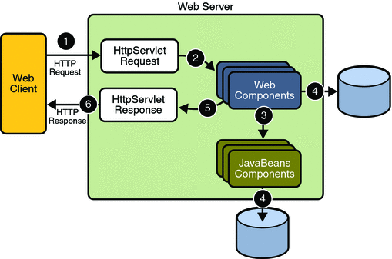

Authentication
Functional Description

  - Login to the system through the first page of the application.
  - Change the password after login to the application.
  - See his/her details and change it.
  - Help from the system.

General Operations:

Student
- User can Register to Alumni
- Students can login to the system
- Update the Profile
- Students can see all students information in the alumni
- They can see the events details
- They can also send messages to their friends
- Students also can see the campus interview details

Admin users
- Has full access to all the modules of this system.
- Responsible for the accounts of all students.
- Update, modify or delete event details
- Update, modify or delete campus interviews details
- Prepares and submits also Daily reports, user reports, event reports, etc.

Normal users:
- Has restricted access. i.e., Normal users have access to some of the modules only i.e. user can search the list of all their friends.
- They cannot send messages to their batch mates

E - R Diagram

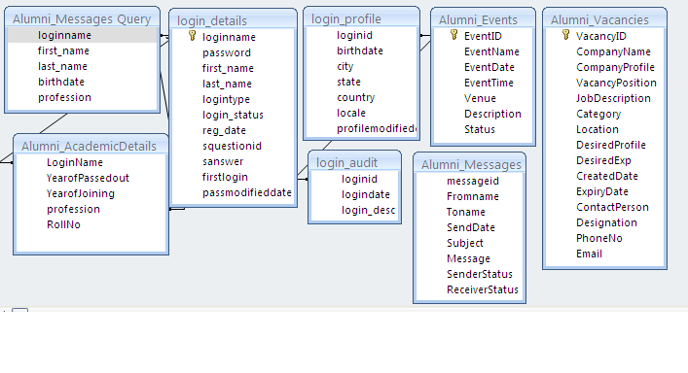

Use-case Diagram
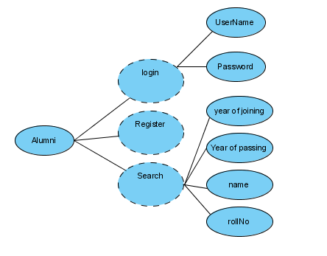

users of the system
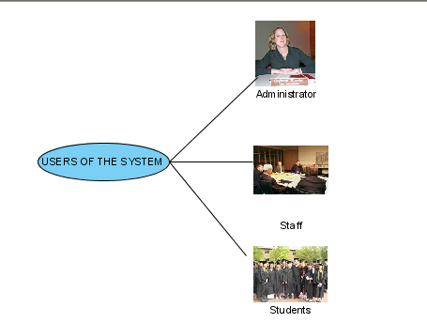

Administrator Use Case

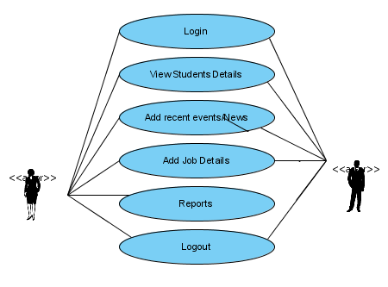

Student/Alumni UseCase
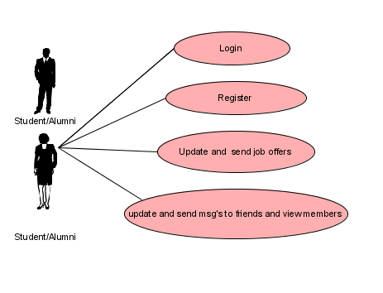

Guest UseCase

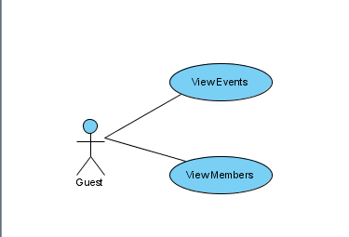

Sequence Diagram For Alumni

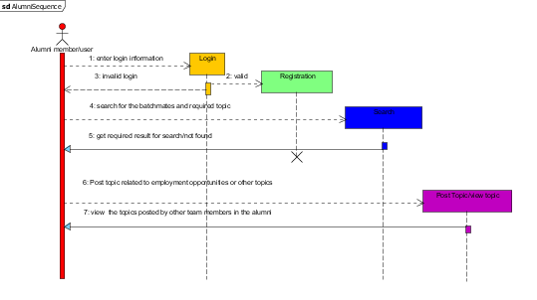

Component Diagram

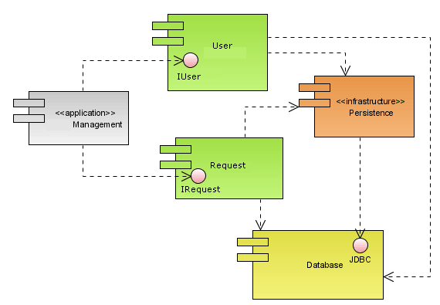
Deployment Diagram

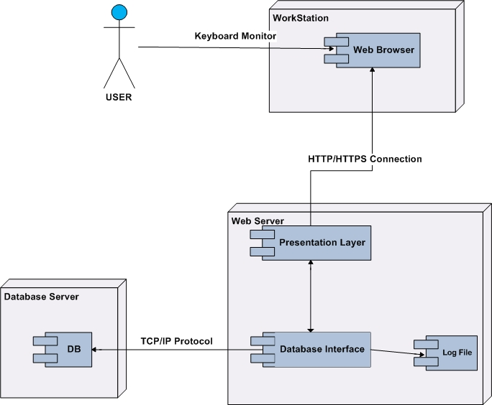

Data Dictionary:

AlumniAcademicDetails:
ColumnName | DataType | Size
LoginName | text | 10
YearofPassdout | number | 04
YearofJoining | number | 04
profession | text | 25
RollNo | text | 25

AlumniEvents:
ColumnName | DataType | Size
EventID | Number | 25
EventName | text | 25
EventDate | date/time | 10
EventTime | text | 25
Venue | text | 25
Description | text | 25
Status | text | 25

AlumniMessages:
ColumnName | DataType | Size
messageid | number | 10
FromName | Text | 25
ToName | Text | 25
SendDate | date/time | 10
Subject | Text | 50
Message | Text | 25
SenderStatus | number | 10
ReceiverStatus | number | 10

Alumni Vacancies:
ColumnName | DataType | Size
VacancyID | Number | 10
CompanyName | text | 25
CompanyProfile | text | 25
VacancyPosition | text | 25
JobDescription | text | 25
Category | text | 25
Location | text | 25
DesiredProfile | text | 25
DesiredExp | text | 25
CreatedDate | date/time | 10
ExpiryDate | date/time | 10
ContactPerson | text | 25
Designation | text | 25
PhoneNo | text | 25
Email | text | 50

LoginProfile:
ColumnName | DataType | Size
loginid | text | 25
birthdates | date/time | 10
city | text | 25
state | text | 25
country | text | 25
locale | text | 25
profilemodifieddate | date/time | 10

LoginAudit:
ColumnName | DataType | Size
loginid | text | 25
logindate | date/time | 10
login_desc | text | 25

LoginDetails:
ColumnName | DataType | Size
loginname | text | 25
password | text | 25
first_name | text | 25
last_name | text | 25
logintype | text | 25
login_status | number | 10
reg_date | date/time | 10
squestionid | text | 25
sanswer | text | 25
firstlogin | number | 10
passmodifieddate | date/time | 10

Questionbase:
ColumnName | DataType | Size
question_Id | number1 | 10
question_detail | text | 25

Snapshots

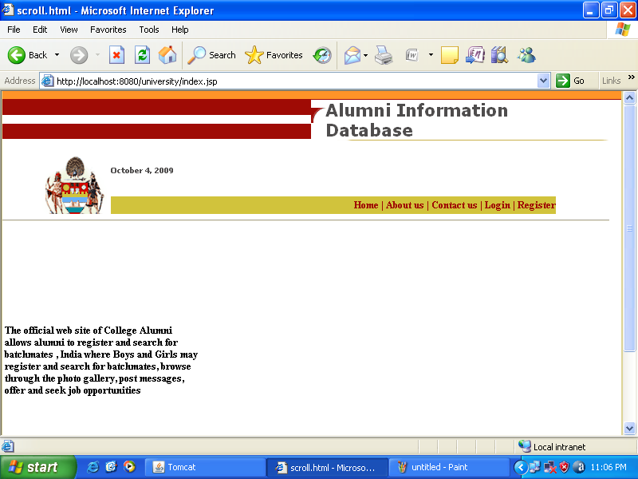

Figure-1

This is the home page of application.

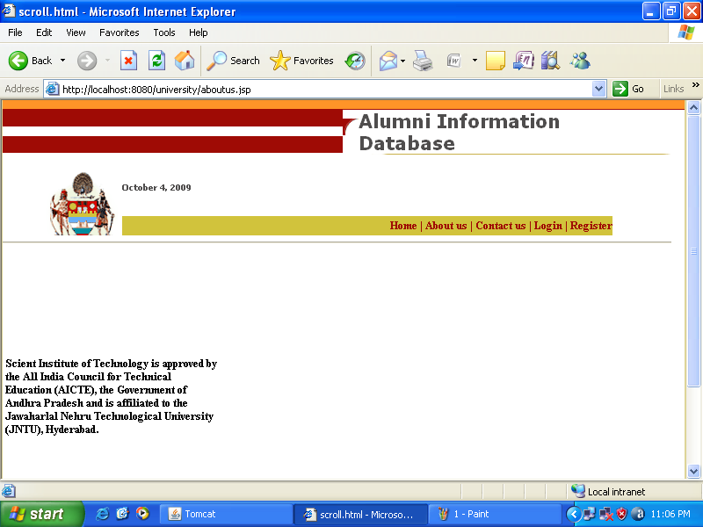

Figure-2

This page shows the details about the college.

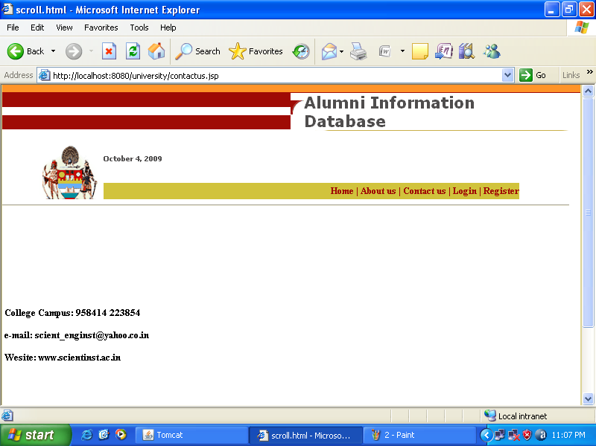

Figure-3

This page will show the contact details of the college.

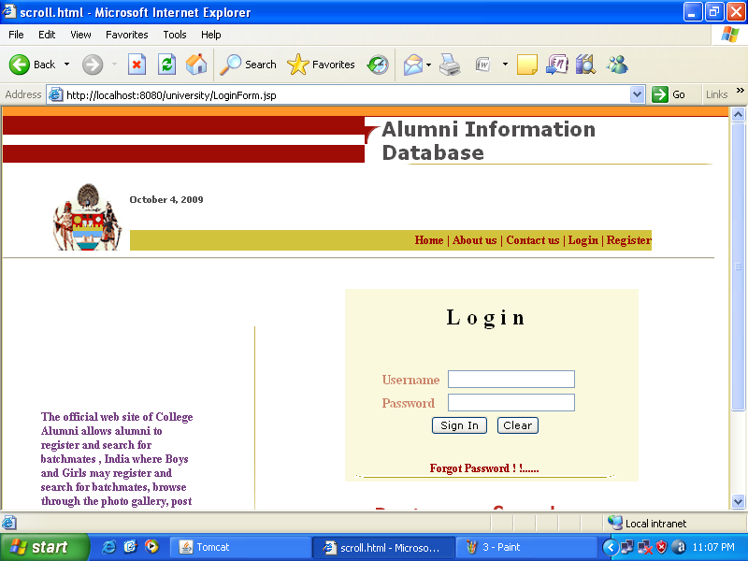

Figure-4

This is login page where students can login with their username and password.

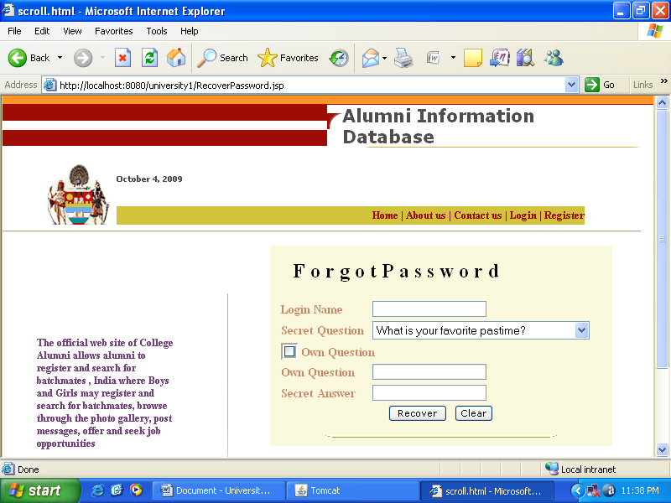

Figure-5

This page is used when the user forgets his/her password.

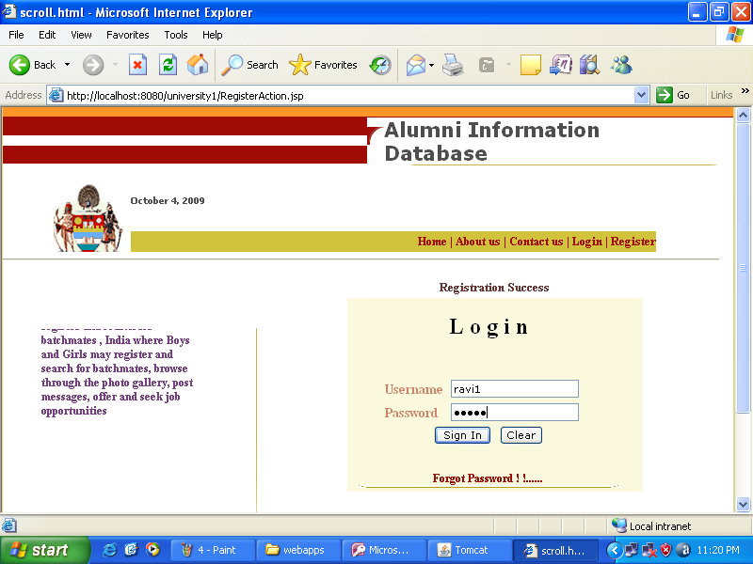

Figure-6

This is the way in which the user should enter his/her details and then click “Sign In” button.

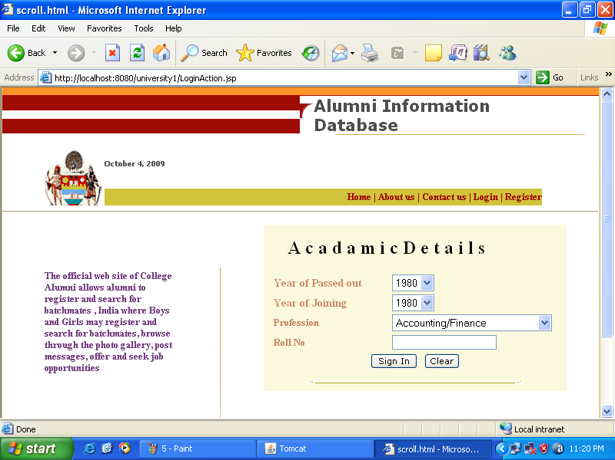

Figure-7

When the user will login in the website for the first time then it will ask the Academic Details and the user have to fill it.

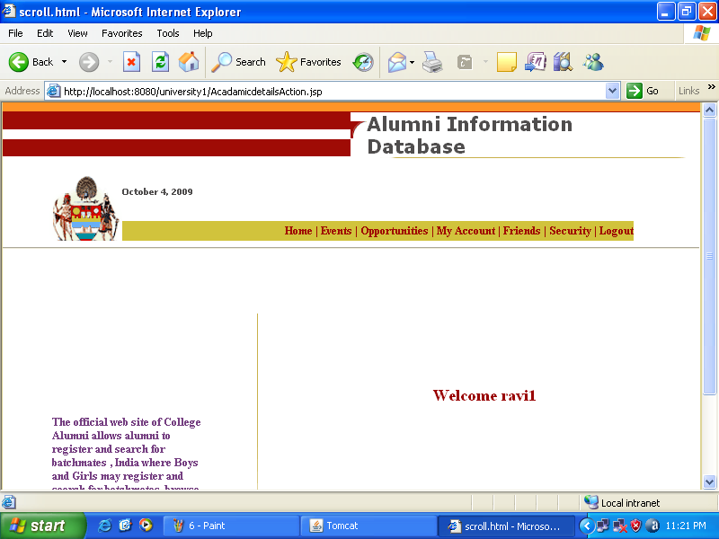

Figure-8

After filling the Academic Details the above page will be displayed.

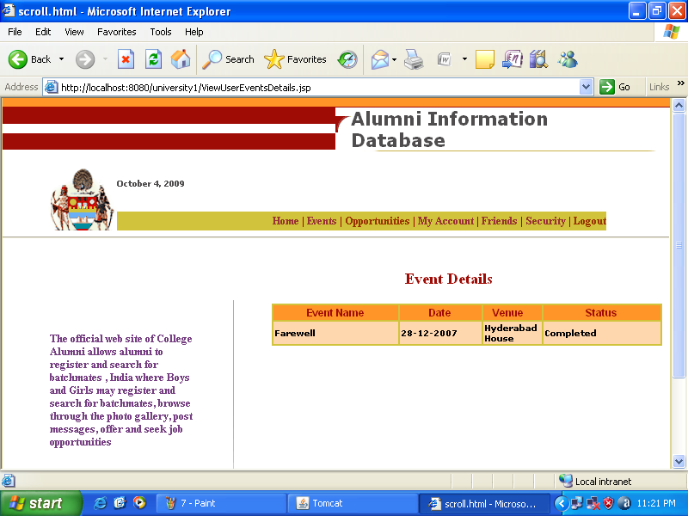

Figure-9

If the user will click the Events option then the above page is displayed with the list of events and their status.

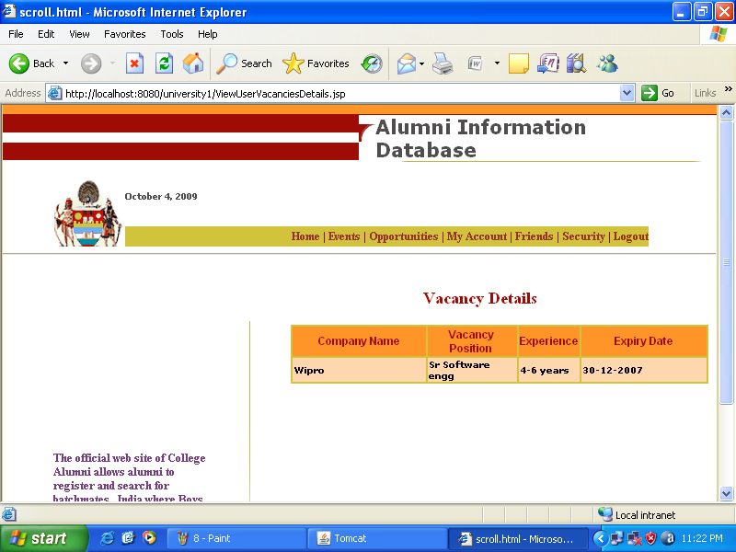

Figure-10

If the user will click the Opportunities option then the above page is displayed with the list of Opportunities and their eligibility criteria.

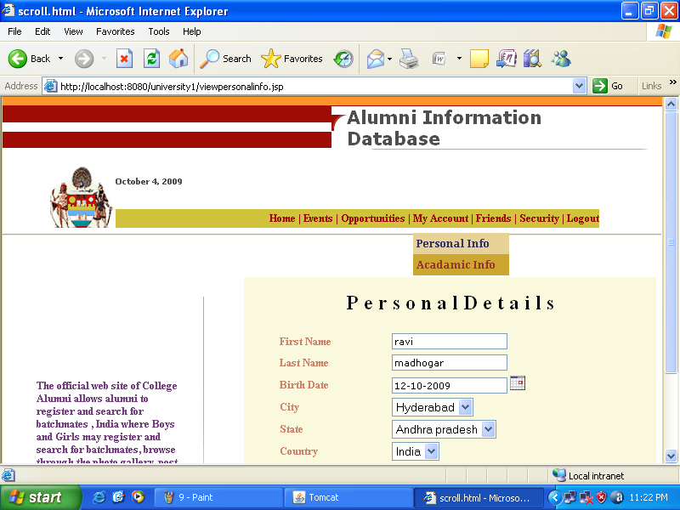

Figure-11

If the user will click the Personal Info option under My Account then the above page is displayed.

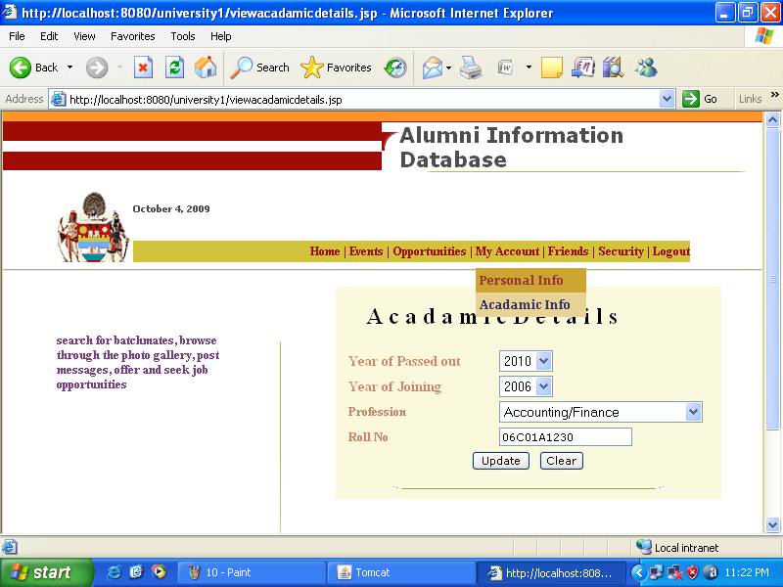

Figure-12

If the user will click the Academic Details option under My Account then the above page is displayed.

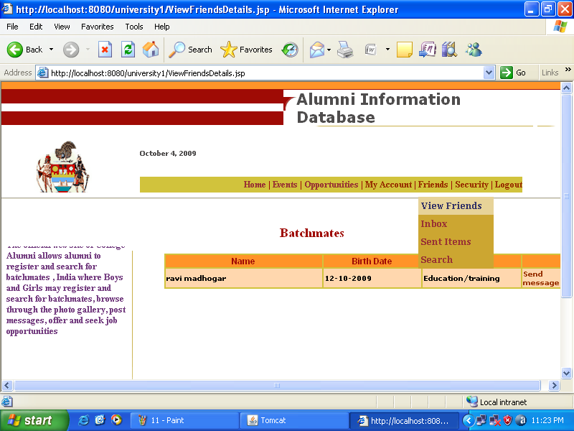

Figure-13

If the user will click the View Friends option under Friends then above page is displayed with his details.

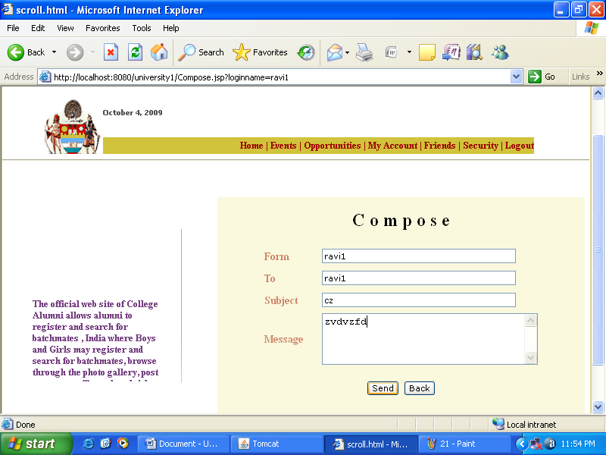

Figure-14

After clicking the send message option in the previous page the above page is displayed, the user needs to write the ToAddress and write subject and message.

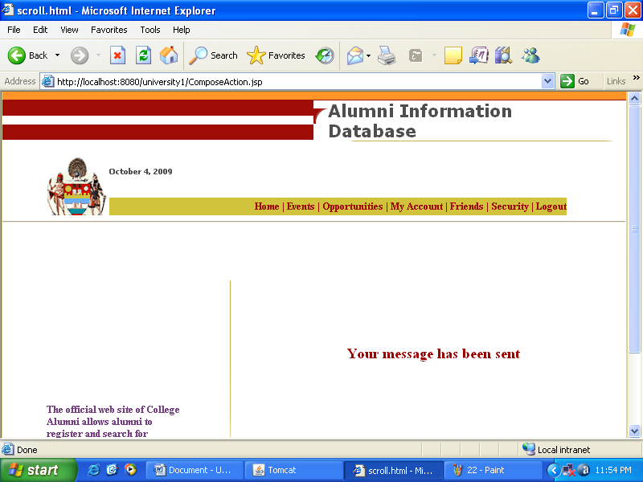

Figure-15

After clicking the send button in the previous page the above page is displayed.

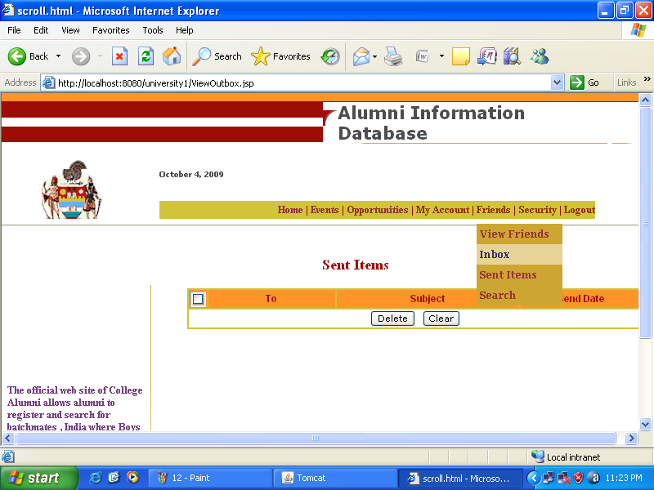

Figure-16

The above page is used to view if any message is received.

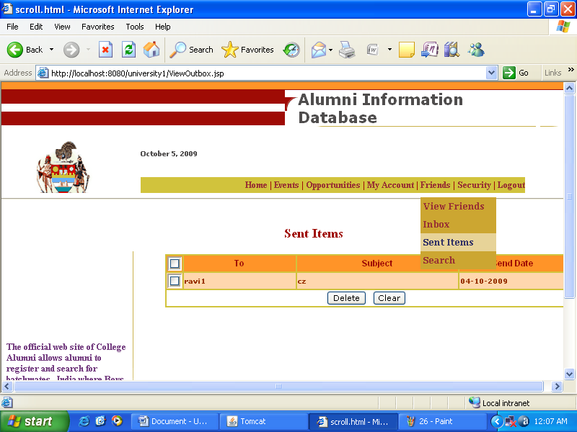

Figure-17

The above page is used to view the messages which are sent by the user.

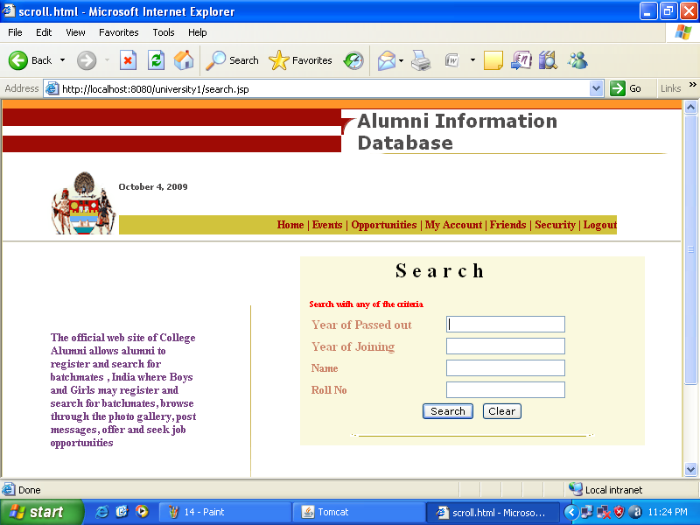

Figure-18

The above page is used to search the friends by entering the details of him.

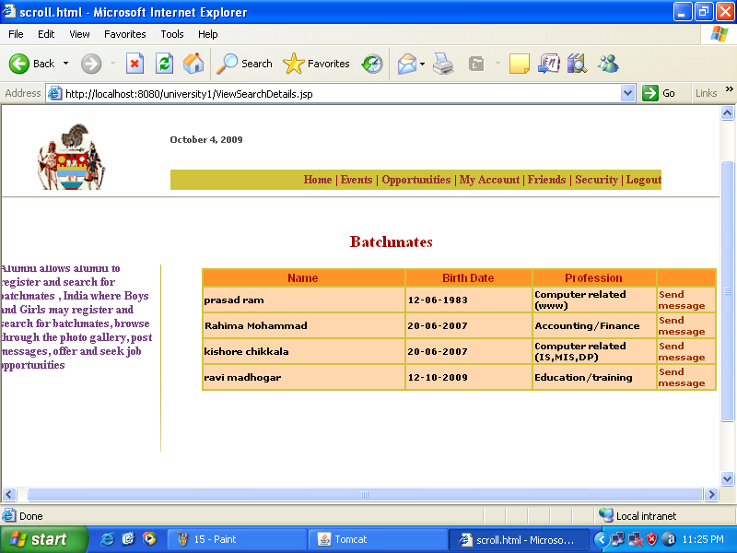

Figure-19

The above page is displayed after clicking the search button in the previous page.

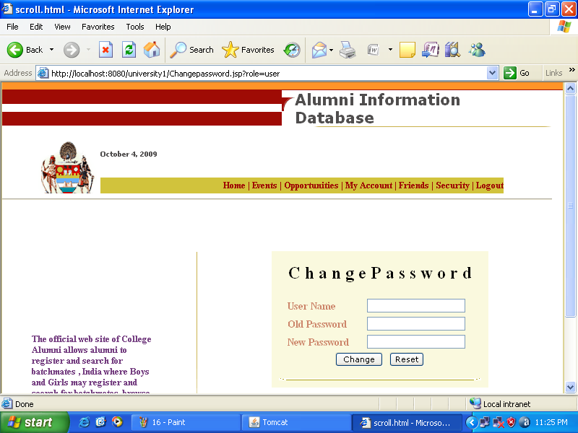

Figure-20

The above page is used to change the password. To perform this operation the user has to enter the following details:

- User Name
- Old Password
- New Password

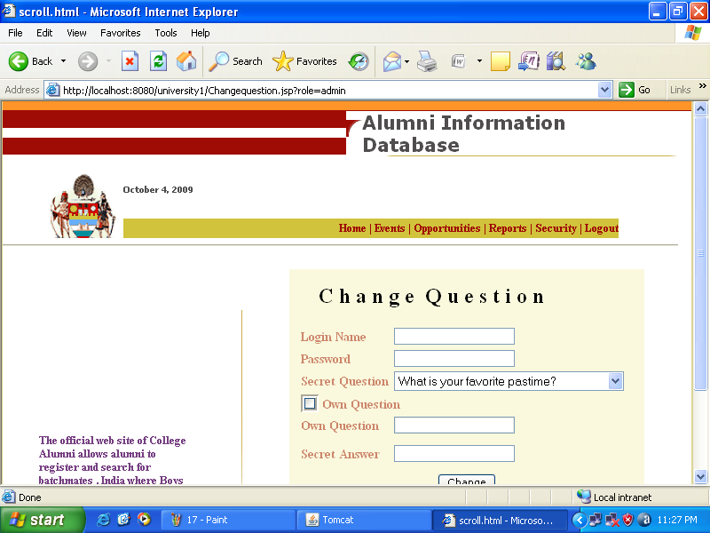

Figure-21

The above page is used to change the secret question.

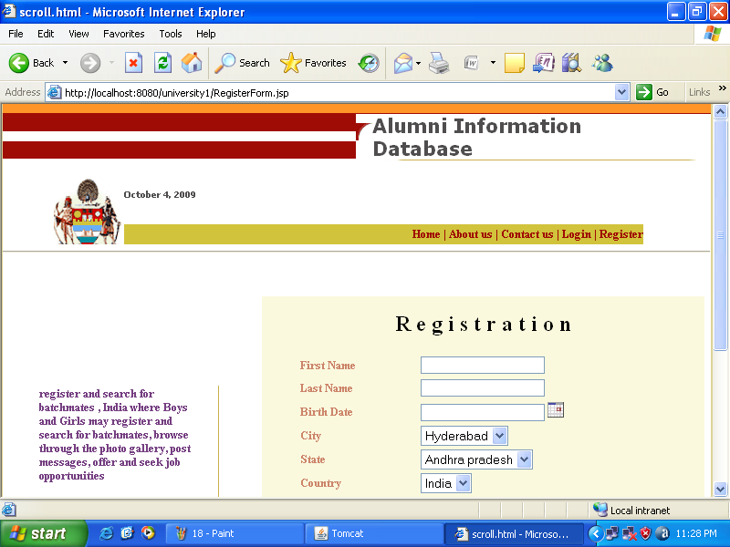

Figure-22

The above page is used for the registration of the new student of the college.

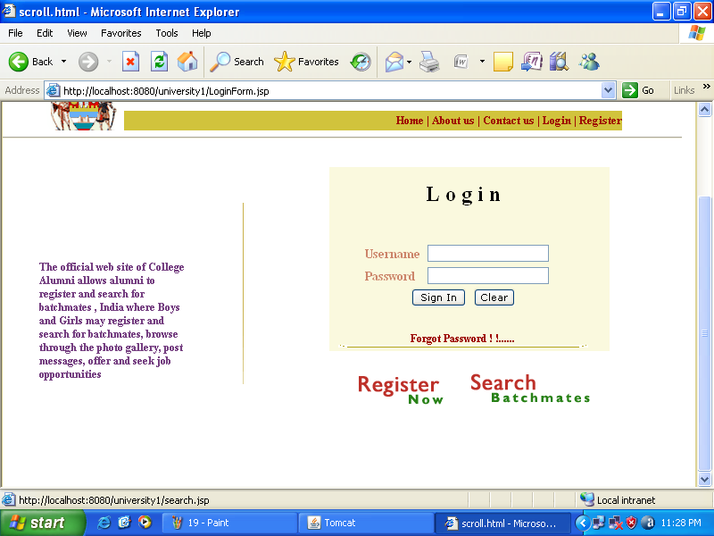

Figure-23

If the user is the outsider then he can just search the students by clicking to the Search Batchmates Tag.

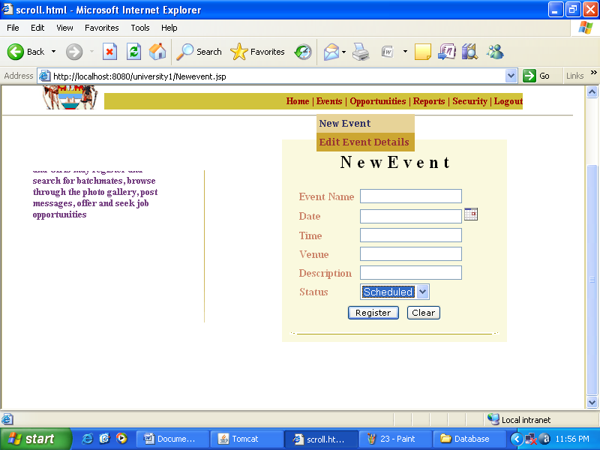

Figure-24

After login as an administrator, the administrator can add any event by typing the following details:

- Event Name
- Date
- Time
- Venue
- Description
- Status

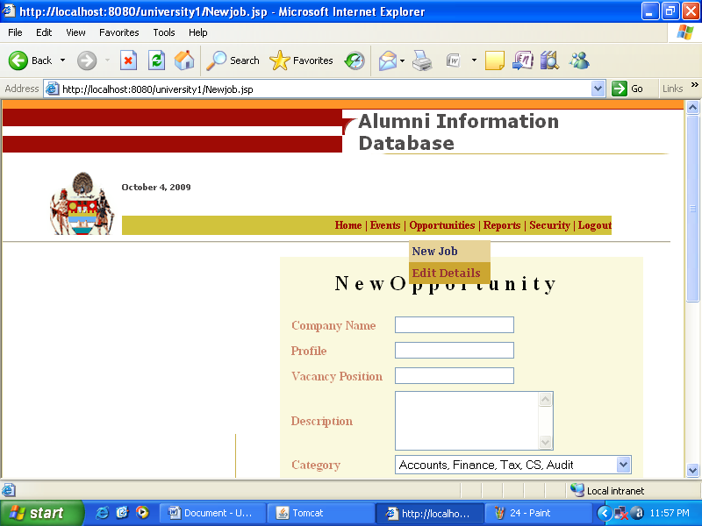

Figure-25

After login as an administrator, the administrator can add any new opportunity by typing the following details:

- Company Name
- Profile
- Vacancy Position
- Description
- Category

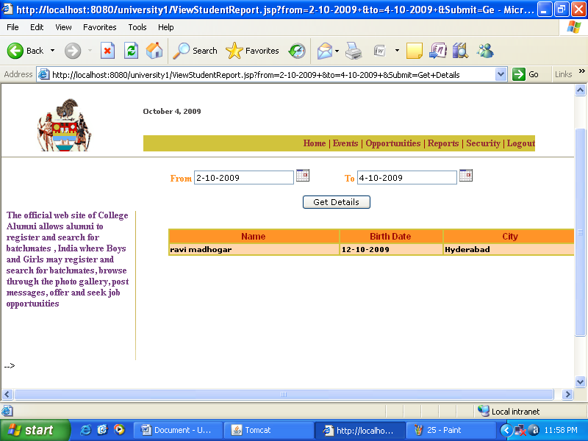

Figure-26

The administrator can get records of the students by filling the above page.

Future Enhancements:
It is not possible to develop a system that makes all the requirements of the user. User requirements keep changing as the system is being used. Some of the future enhancements that can be done to this system are:
- As the technology emerges, it is possible to upgrade the system and can be adaptable to desired environment.
- Because it is based on object-oriented design, any further changes can be easily adaptable.
- Based on the future security issues, security can be improved using emerging technologies.
- Attendance module can be added
- sub admin module can be added

Bibliography:

Core Java™ 2 Volume II – Advanced | - Cay S. Hortsman
Pearson Education – Sun Microsystems | Gary Cornell
The Complete Reference-Java | - Herbert Schildt
www.wikipedia.org
Conclusion:

So the Alumni Information Database is mainly used to share the views between the users of the application which is very useful to upgrade the knowledge of everyone. The application is also serve as a useful site to know what is going on in our in our college and can also know about the various opportunities of the outer world. The application can be further expanded by following the future Enhancements mentioned above.

